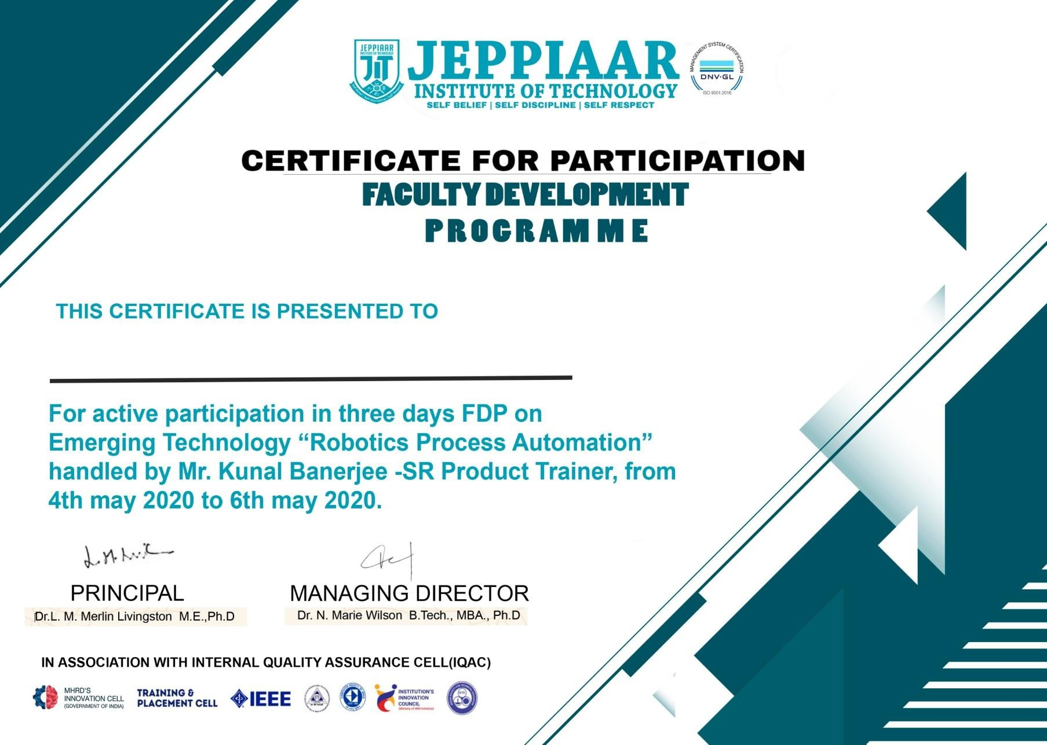

Mr. YOGANATHAN NS